INDIAN INSTITUTE OF INFORMATION TECHNOLOGY, ALLAHABAD
VI Semester B.Tech in Information Technology Report - Group Assignment 2

Data Mining and Warehousing

Deep One-Class Classification

Group Members

Abhinav Bansal : IIT2018155
Neelabh Gupta : IIT2018168
Ankit Raj : IIT2018174
Ashish Patel : IIT2018175
Shubham Soni : IIT2018177

1. INTRODUCTION

Anomaly detection (AD) (is the task of discerning unusual samples in data. Typically, this is treated as an unsupervised learning problem where the anomalous samples are not known a priori and it is assumed that the majority of the training dataset consists of “normal” data (here and elsewhere the term “normal” means not anomalous and is unrelated to the Gaussian distribution). This is known as one-class classification. AD algorithms are often trained on data collected during the normal operating state of a machine.

- PROPOSED PROBLEM :

In this problem we have to detect anomalies in our data . We have proposed a novel approach to deep AD inspired by kernel-based one-class classification and minimum volume estimation. Our method, Deep Support Vector Data Description (Deep SVDD), trains a neural network while minimizing the volume of a hypersphere that encloses the network representations of the data .

- ALGORITHM

  - First of all , We build on the kernel-based SVDD and minimum volume estimation by finding a data-enclosing hypersphere of smallest size.
  - Then , we employ a neural network that is jointly trained to map the data into a hypersphere of minimum volume.
  - Then Deep SVDD optimization and selection of the hypersphere is done .
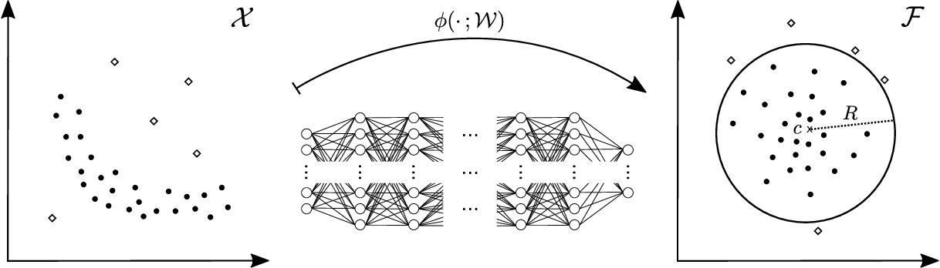

Fig : Deep SVDD learns Neural Network Transformation

2

4. RESULT :

ROC SCORES FOR EACH CLASSES WERE:
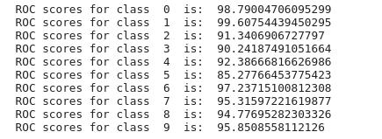

Outliers V/S inliers for each class :
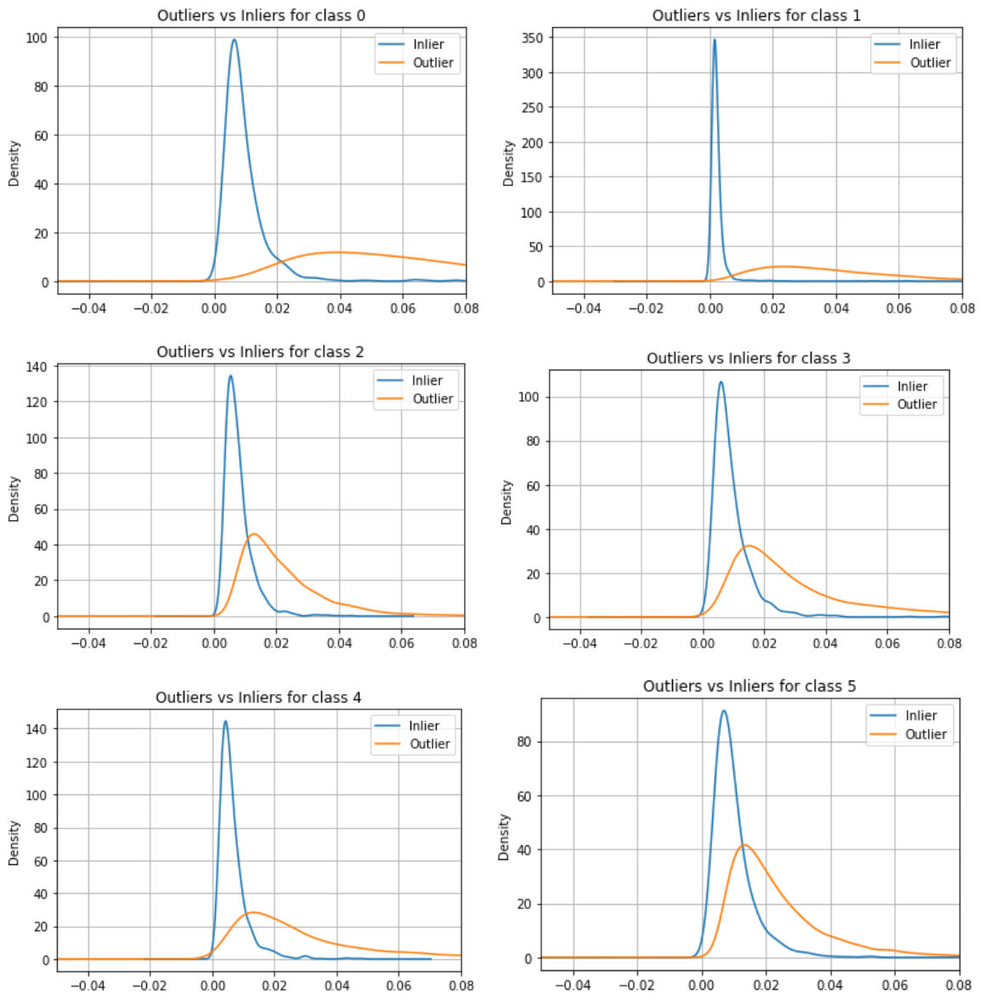

3

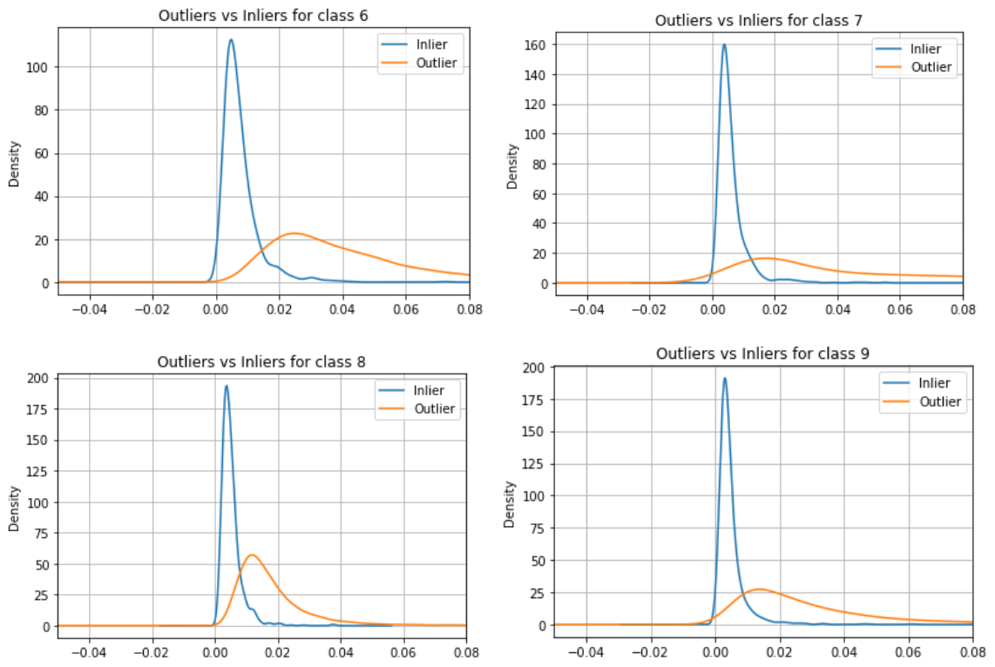

Table 1 : Average AUCs in % with StdDevs (over 10 seeds) per one-class experiment on MNIST .

According to this table , The One-Class Deep SVDD (IMPLEMENTED) showed better/similar performance as compared to One-Class Deep SVDD (In Paper).
Normal Class | DEEP ONE-CLASS | DEEP ONE-CLASS
 | (IN PAPER) | (IMPLEMENTED)
0 | 98.0±0.7 | 98.79004706095299
1 | 99.7±0.1 | 99.60754439450295
2 | 91.7±0.8 | 91.3406906727797
3 | 91.9±1.5 | 90.24187491051664
4 | 94.9±0.8 | 92.38666816626986
5 | 88.5±0.9 | 85.27766453775423
6 | 98.3±0.5 | 97.23715100812308

4

7 | 94.6±0.9 | 95.31597221619877
8 | 93.9±1.6 | 94.77695282303326
9 | 96.5±0.3 | 95.8508558112126

So, here we can see that we had implemented the algorithm and achieved the accuracy (almost better ) as mentioned in the research paper.

5

